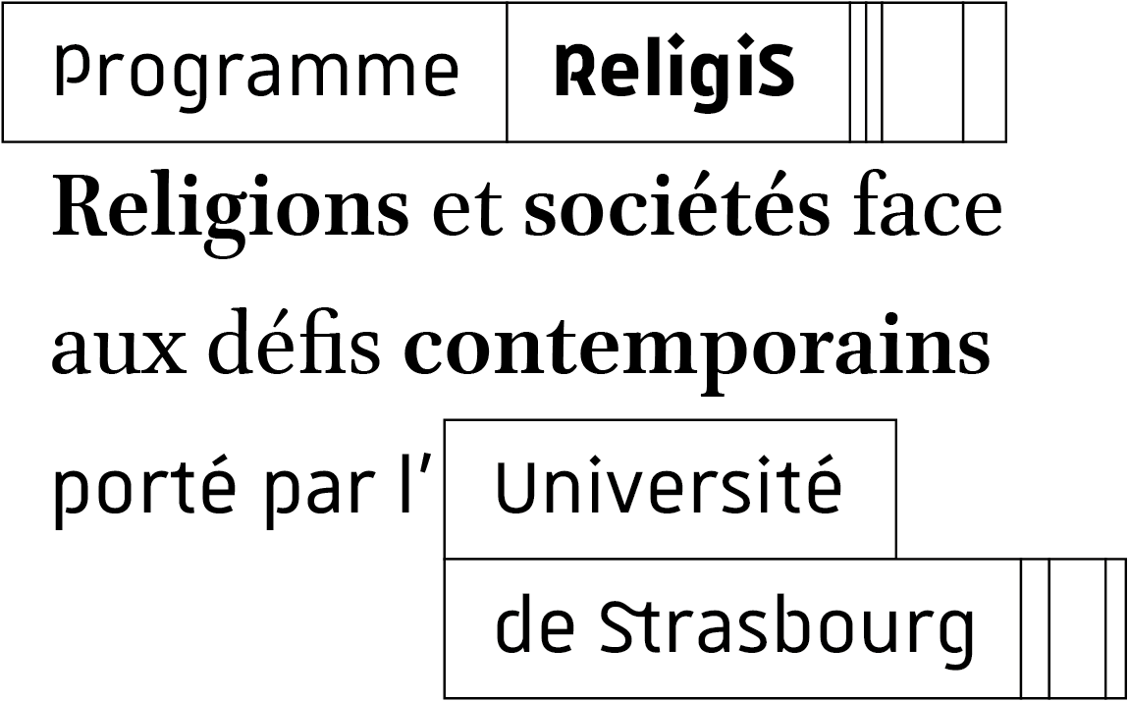



RELIGIS RESEARCH MOBILITY/Fellowship

1. Applicant information
Surname:
First name:
Date of birth:
Nationality:
Address:
Telephone:
E-mail :

2. Professional status
For staff on fixed-term contracts, please indicate the end date of your employment contract:
Status:
Affiliated institution:
Research unit:
Discipline:
Country:

3. Request mobility
Preferred period:

4. Research project
*Project title :
* Project summary (maximum 300 words)

ReligiS axis/axes concerned:
☐ Axis 1 – Situating Religion: Forms and Spaces
☐ Axis 2 – Interacting with Religion: Pluralism, Politics, and Ethics
☐ Axis 3 – Analysing Religion: Knowledge and Epistemologies
Project description (maximum 15,000 characters)
The research proposal must justify the choice of the Paris Institute for Advanced Study (IEA), indicate the concrete contribution to the selected ReligiS thematic axis, and detail the methods and data used.
5 . Applicant’s commitments
☐ Respect the duration and conditions of the planned residency
☐ Acknowledge ReligiS funding in any publication resulting from the residency period (France 2030 – ANR-24-RSHS-0005)
Date :
Signature :

Please attach to this information form:
☐ Curriculum vitae with list of publications (maximum 3 pages)

